BSDA2001P — Introduction to DL and GenAI
Smart MCQ Solver — Project Report
Fine-Tuned Transformer, a Custom RNN, and a Classical Baseline for MCQ Answer Ranking (MAP@3) — Kaggle: Smart MCQ Solver Challenge | 23f2004341 | [Date]

1. Abstract / Executive Summary
This project tackles the Smart MCQ Solver Challenge on Kaggle. Each question comes with five candidate answers (A–E), and the goal is to rank the top three most likely to be correct. Since scoring is done with MAP@3, getting the ranking right matters, not just picking the single best answer.
I built and compared three different approaches. The first is a TF-IDF + Logistic Regression model that treats every prompt-option pair as its own binary classification problem — is this option correct or not. The second is a BiLSTM I wrote from scratch, using the same binary framing but with a custom vocabulary and a loss function weighted to handle the class imbalance (only 1 in 5 options is actually correct). The third, and best-performing, is a fine-tuned microsoft/deberta-v3-base transformer using Hugging Face's AutoModelForMultipleChoice head, which scores all five options for a question together through a shared softmax instead of judging them one at a time. This framing lines up much better with how MAP@3 actually works. All three models' outputs are then blended together in a weighted ensemble.
One of the more interesting things that came out of the EDA was just how much duplication there is in the data — only 588 unique option-sets across 2,000 training rows, and it turns out 91.6% of the test set's option-sets already show up somewhere in training with a known, unique answer. I ended up building a lookup table to take advantage of this directly, overriding the model's prediction whenever a test question matches something already seen.
On validation, TF-IDF hit 91.9% accuracy (F1 = 0.820) on the binary task, the BiLSTM reached 85.4% accuracy (F1 = 0.733), and DeBERTa scored an out-of-fold MAP@3 of 0.7245 using 5-fold cross-validation grouped by option-set so duplicates couldn't leak between folds. The final ensemble weights TF-IDF, LSTM, and DeBERTa at 0.10 / 0.00 / 0.90 — so in practice DeBERTa drives almost all of the final predictions, TF-IDF nudges close calls, and the LSTM's weight is effectively zero.
The biggest lessons from this project: cross-validation needs to be group-aware when the data has this much duplication, framing MCQ as a joint ranking problem beats scoring options independently, and understanding quirks in how a dataset was constructed (like the train/test overlap here) can move the leaderboard score more than any modelling tweak.

2. Introduction

2.1 Problem Statement & Metric
train.csv has 2,000 rows and test.csv has 500, each with an id, a prompt, five answer options (A–E), and — for training rows only — the correct letter. For every question in the test set, the model needs to output the three letters it thinks are most likely correct, in order (something like "B E D"). The competition scores this with MAP@3: a question gets 1 point if the true answer is ranked first, 1/2 if it's second, 1/3 if third, and 0 if it doesn't make the top three at all. Average that over every question and that's the leaderboard score.

2.2 Objectives
The main goals going in were to build and fairly compare a classical baseline, a custom RNN, and a fine-tuned transformer on the exact same task — but framed correctly for each one, since binary relevance scoring and joint 5-way ranking aren't the same problem. Given how duplicated the data turned out to be, using group-aware cross-validation became a priority so the local metric would actually mean something. I also tracked everything through Weights & Biases and combined the three models into a weighted ensemble at the end.

3. Dataset & Preprocessing

3.1 Dataset & EDA
train.csv is 2,000 rows with id, prompt, A–E, and answer; test.csv is 500 rows with no answer column. Each question is handled as five separate (prompt, option) pairs.
The biggest thing that jumped out during EDA was how repetitive the training set actually is. I built a normalized "option-set key" — basically the five options sorted and lower-cased — so that the same underlying question would collapse to one key even if the prompt wording was changed around it. That turned up only 588 unique option-sets across all 2,000 rows, meaning most questions show up several times with reworded prompts. Good news is that within every one of those 588 groups, the correct answer was always consistent — no conflicting labels anywhere. And when I checked the test set against this, 458 of the 500 rows (91.6%) matched an option-set already seen in training.
This has a real consequence for validation: if you split the data randomly, near-duplicate copies of the same question can end up on both sides of the split, and the model just "recognizes" content it already memorized rather than actually generalizing. I saw this happen directly — a plain K-fold split gave a local MAP@3 of about 0.97, which is way too good to be true and nowhere close to the real leaderboard score (~0.75). Once I grouped folds by option-set instead, the number dropped to a much more believable 0.7245 (more on this in 5.1). I also logged the answer-letter distribution and word frequencies to wandb (data/answer_distribution, data/top_words) as a sanity check.

3.2 Preprocessing & Augmentation
For TF-IDF and the BiLSTM, each question gets expanded into five binary-labelled rows (10,000 examples total), with the label set to 1 if that particular option is the correct one. The prompt and option text are combined per pair. For DeBERTa the five options stay grouped together and get tokenized as five (prompt, option) pairs sharing one label from 0–4, which matches what AutoModelForMultipleChoice expects natively. I didn't apply any synthetic augmentation — the dataset already had so much natural duplication that it made more sense to exploit that directly through the lookup table instead (Section 5.3).

4. Tokenization Strategy
The best-performing model, DeBERTa-v3-base, comes with its own pre-trained SentencePiece-style tokenizer (about 128K subword pieces, trained jointly with the encoder). This made more sense than a hand-built vocabulary given how technical some of the prompts get — terms like "redshift" or "Landau–Lifshitz–Gilbert" would either get dropped entirely by a small custom vocab or split so sparsely that the model couldn't learn much from them. Subwords let the tokenizer fall back gracefully on rare terms while still keeping common words as single tokens, and because the pieces are pre-trained, they already carry useful semantic information before fine-tuning even starts. In practice this meant loading transformers v4.46.3's AutoTokenizer alongside AutoModelForMultipleChoice, tokenizing each question's five (prompt, option) pairs together with truncation at max_length=320, and letting a multiple-choice-aware data collator handle padding dynamically per batch rather than always padding to the max.
Model | Tokenizer | Vocabulary | Notes
TF-IDF+LR | TfidfVectorizer | 50,000 feat., 1–2 grams | English stop-words removed; bigrams catch short phrases.
BiLSTM | Hand-built whitespace | 3,816 tokens (min count 2) | Lower-cased; rare words → <UNK>; fixed-length pad/truncate.
DeBERTa-v3 | Pre-trained SentencePiece | ~128,000 subwords | Joint encoder pre-training; handles rare/technical terms via subword back-off.

5. Modeling & Experimentation
Below are the three approaches I built, in the order the guidelines ask for. One honest note on Section 5.2: the guidelines want a custom deep-learning architecture there, separate from the RNN in 5.3. What I actually have is a classical TF-IDF + Logistic Regression baseline, which I'm using as the non-transformer comparison point instead. If strict compliance matters, adding something like a text-CNN would close that gap.

5.1 Model 1: Fine-Tuned Transformer — DeBERTa-v3-base
Architecture: I used microsoft/deberta-v3-base (He et al., 2021) with Hugging Face's AutoModelForMultipleChoice head. DeBERTa's main innovation over BERT is disentangled attention — instead of adding position information into the token embedding, it keeps content and position as separate vectors — plus an enhanced mask decoder that reintroduces absolute position info later in the network. DeBERTaV3 also swaps the usual masked-language-model pretraining for an ELECTRA-style replaced-token-detection objective, which gives stronger representations without growing the model. The multiple-choice head runs the shared encoder once per option, turns each pass into a single score, and applies softmax across all five scores together — so the model is directly learning to rank the correct option above the other four, rather than judging each one in isolation. This matters here because several of the distractor options are nearly identical in wording and differ only in a specific detail (e.g. "z = 6.0" vs. "z = 16.7"), which disentangled attention is well suited to picking up on.
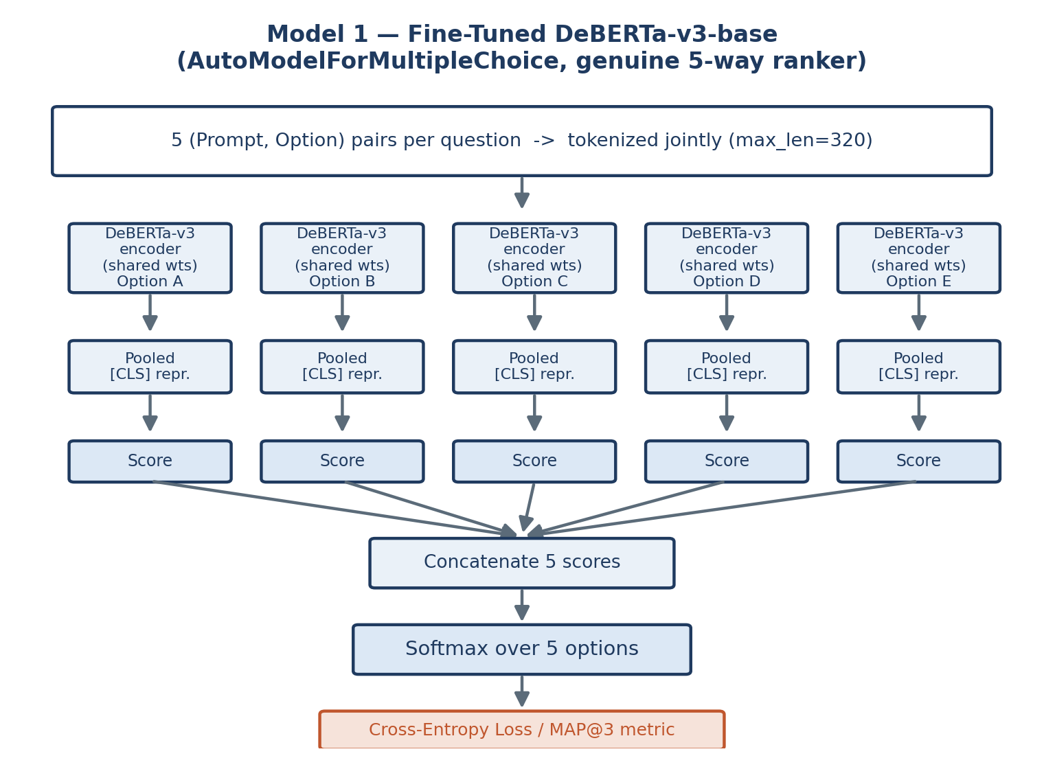
Fig. 1 — DeBERTa scores all 5 options through a shared encoder, ranked via joint softmax.
Fine-tuning: AdamW with lr=1e-5, weight decay 0.01, a cosine schedule with 10% warmup, 6 epochs, batch size 4 with gradient accumulation of 2 (effective batch 8), and fp16 throughout. No layers were frozen. The main methodological decision was using 5-fold GroupKFold grouped by option-set key rather than a plain fold split — without that, duplicate questions leak across the train/validation boundary and the local score becomes meaningless (it inflated to ~0.97 versus a real leaderboard score around 0.75). Checkpoints were selected using a custom compute_metrics function implementing the actual MAP@3 formula (metric_for_best_model="map3"), so the model saved at the end of each fold is the one that's actually best on the competition's own terms. No quantization was applied — training ran in fp16 mixed precision on a Tesla T4.

5.2 Model 2: Baseline — TF-IDF + Logistic Regression
Architecture: Each (prompt, option) pair goes through a TfidfVectorizer (max_features=50,000, ngram_range=(1,2), English stop-words removed) and then a Logistic Regression classifier (class_weight="balanced", max_iter=1000) that predicts the probability the option is correct. class_weight="balanced" turned out to matter quite a bit, since only 1 in 5 pairs is actually a positive example — without it the model would just learn to predict "wrong" for almost everything. Including bigrams also helps pick up short but meaningful phrases like "light-ion fusion" that a plain unigram bag-of-words would treat as unrelated individual words. This model is really just meant to be a fast, easy-to-interpret floor — it has no shared context across a question's five options and no real sense of word order — so it's a useful reference point for how much of the task can be solved by surface-level word overlap alone.
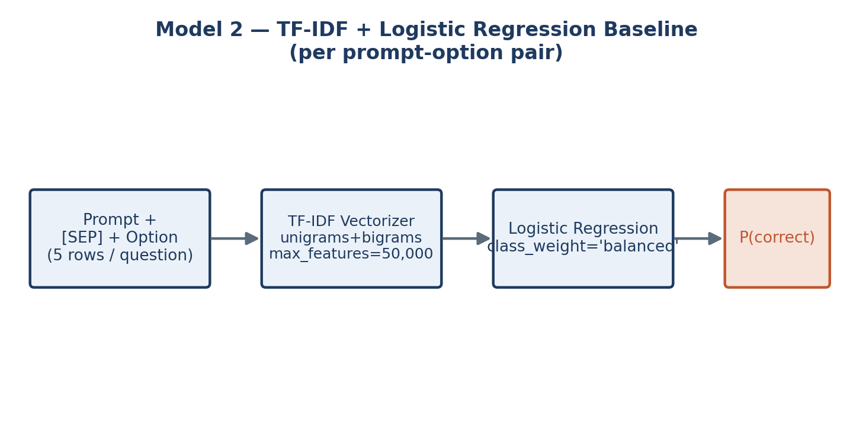
Fig. 2 — TF-IDF + Logistic Regression: a fast, purely lexical baseline.

5.3 Model 3: RNN-Based — Bidirectional LSTM
Architecture: I wrote this one from scratch in PyTorch: an nn.Embedding layer (vocab size 3,816, embedding dim 256, pad_idx 0) feeding a 2-layer bidirectional nn.LSTM (hidden size 256 per direction, dropout 0.4 between layers). The output from the last timestep (512-d after concatenating both directions) goes through dropout and a single Linear(512, 1) layer, trained with BCEWithLogitsLoss and pos_weight=4.0 to deal with the same 1-in-5 imbalance the TF-IDF model handles differently. It comes out to 3,607,041 trainable parameters. The bidirectional part lets the encoder use context from both directions before it scores an option, and I chose a sequence model here specifically because a lot of what separates correct from incorrect options is relational or negated phrasing — "exist without the concept of the past" versus "do not exist without the concept of the past" — which a bag-of-words approach can't really distinguish. Prompts and options are each truncated to 64 tokens and concatenated into a 128-token input. Trained with AdamW at lr=1e-3, a CosineAnnealingLR schedule over 10 epochs, and gradient clipping at norm 1.0. The vocabulary itself was built from scratch on the combined train+test text, keeping only words seen at least twice — so unlike DeBERTa, this model has no pre-trained knowledge of language to lean on.
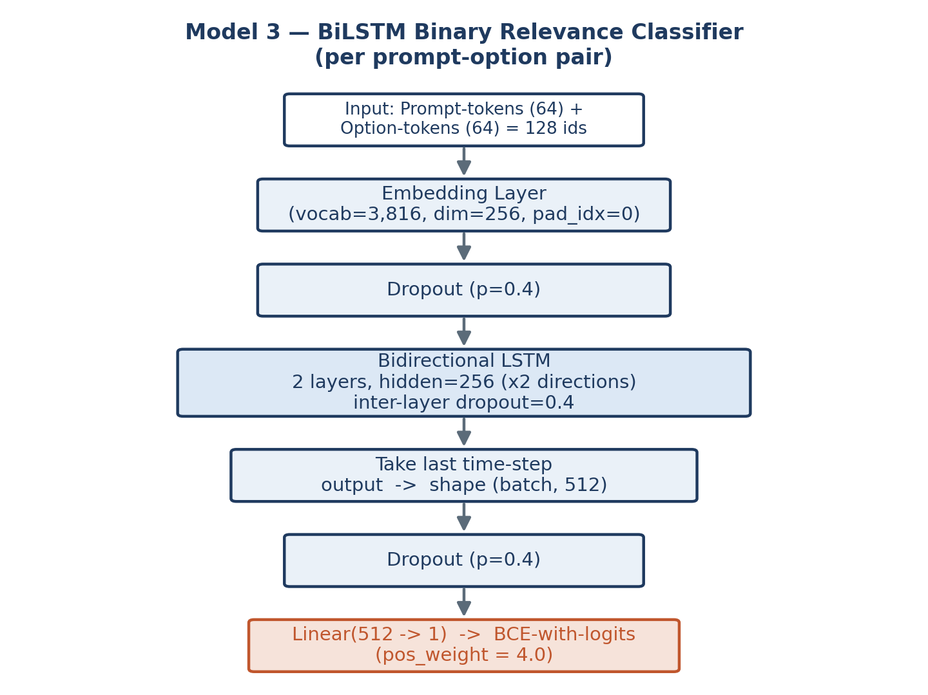
Fig. 3 — Custom BiLSTM: embed → bidirectional encode → single relevance score.

6. Performance & Comparative Analysis
MAP@3 is the competition's actual metric (Sec. 2.1), but the TF-IDF and BiLSTM models were trained as binary classifiers, so their notebooks report accuracy/F1/precision/recall on held-out prompt-option pairs rather than MAP@3 directly. DeBERTa, since it's trained as a genuine 5-way ranker, reports OOF MAP@3 from group-aware 5-fold CV — this is the number that's actually comparable to what you'd see on the leaderboard.
Model | Task framing | Validation metric | Value
TF-IDF + LR | Binary relevance | Acc / F1 | 0.919 / 0.820
BiLSTM (10 ep.) | Binary relevance | Acc / F1 (best, ep.9) | 0.855 / 0.733
DeBERTa-v3-base | Joint 5-way ranking | OOF MAP@3 (5-fold) | 0.7245
These numbers aren't really apples-to-apples — the first two are scoring individual pairs while MAP@3 scores the whole question — but the pattern still tells a story. TF-IDF's high accuracy is mostly coming from how easy the majority "incorrect" class is (4 out of 5 options), so its F1 on the correct class (0.820) is a fairer read. DeBERTa's number looks lower here, but it's solving the genuinely harder version of the problem, and it's the only one of the three whose score you can interpret directly in the competition's own terms.

BiLSTM training
Trained for 10 epochs on a 90/10 split, logging per-step loss, gradient norm, and learning rate to wandb. The early epochs were rough — validation accuracy actually dropped to 0.237 at epoch 3 before recovering, which makes sense given the from-scratch embeddings and a fairly high learning rate (1e-3) still settling in. It eventually reached its best F1 of 0.733 at epoch 9 (accuracy 0.855). Looking at the final classification report, the model gets perfect recall (1.00) on the correct-answer class but precision is only 0.58 — the confusion matrix (654 true negatives, 146 false positives, 0 false negatives, 200 true positives) shows it's over-predicting "correct" fairly often, which is exactly what pos_weight=4.0 pushes it toward.

DeBERTa 5-fold OOF MAP@3
Fold 1 | Fold 2 | Fold 3 | Fold 4 | Fold 5 | Overall OOF
0.7158 | 0.7654 | 0.8279 | 0.6363 | 0.6771 | 0.7245
There's a fair bit of spread between folds (0.636 to 0.828), which isn't too surprising with only around 400 validation questions per fold — a few clusters of harder questions landing in one fold can shift its score quite a bit. The overall OOF figure is the number I'd actually trust as a generalization estimate, since it's built from predictions where the model never saw that question's option-set during training.

6.2 Train/Test Duplicate Lookup (Largest Single Lever)
Given that 91.6% of test option-sets exactly match something already in training with a verified answer (Sec. 3.1), I built a simple lookup table mapping option-set to correct answer and used it to override DeBERTa's top prediction whenever a test row had a match. The model's own ranking still fills in ranks 2 and 3, and handles the 8.4% of rows with no match on its own. I produced two separate submissions — model-only and lookup-augmented — so I could actually A/B test the effect on the real leaderboard, since local CV can't measure the benefit of something that depends on train/test overlap rather than the model generalizing. Worth being upfront about this: it's exploiting a specific quirk of how this dataset was built, not evidence that the model understands the questions any better, and I think it's worth reporting that way rather than quietly folding it into the headline number.

6.3 Ensemble
The final ensemble combines all three models using a weighted rank score: each model's top-3 pick contributes weight × (3 − rank) points per option, scores get summed across models, and the top 3 by combined score become the final prediction. The weights I settled on are tfidf=0.10, lstm=0.00, deberta=0.90 — which in practice means the BiLSTM sits in the pipeline but has zero influence on the actual output. Checking top-1 agreement: TF-IDF matches the ensemble 92.6% of the time, DeBERTa matches 100.0% (which makes sense given it's carrying almost all the weight), and the LSTM matches 79.0% — though that's just a coincidental correlation, since its weight is zero it can't actually be causing anything. I also logged some consensus and confidence diagnostics to wandb (charts/top1_distribution, model_agreement_heatmap, score_margin_distribution, consensus_distribution).
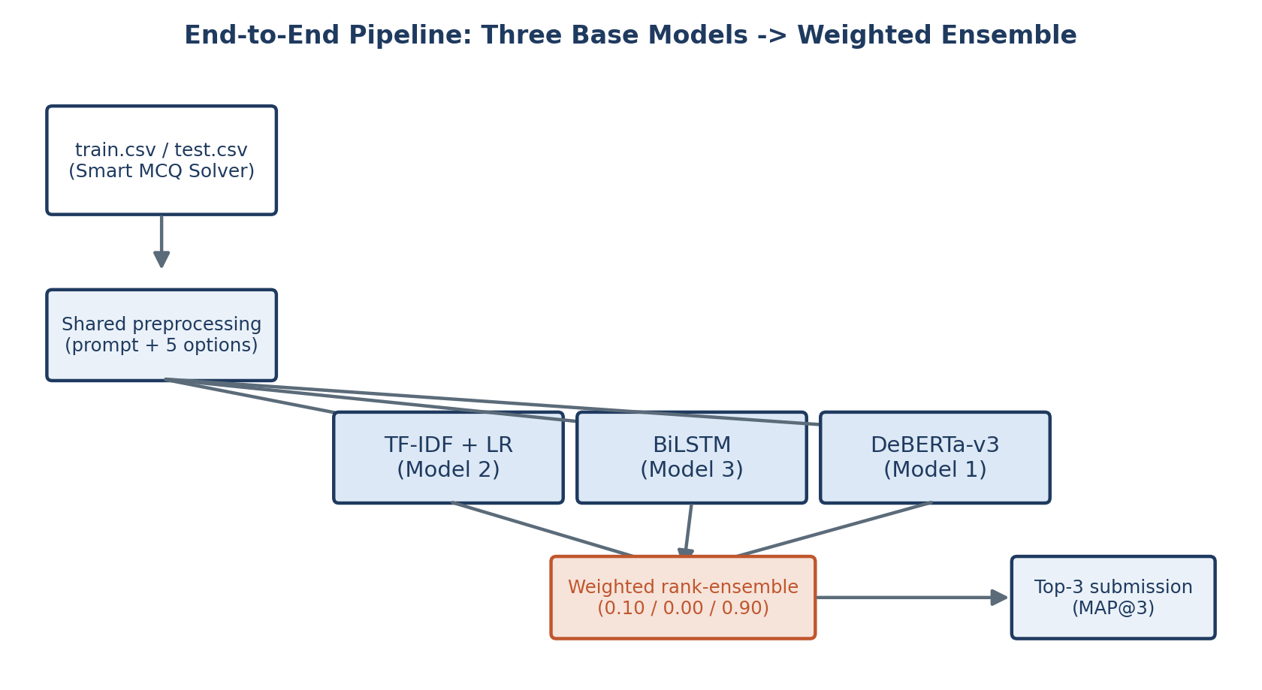
Fig. 4 — Three base models feed a weighted rank-ensemble producing the MAP@3 submission.

Trade-offs
Dimension | TF-IDF+LR | BiLSTM | DeBERTa-v3
Train cost | Seconds (CPU) | Minutes (GPU) | Hours (GPU, 5×6 ep.)
Params | ~11K feat.+weights | 3.6M | ~184M
Pre-trained? | No | No (from scratch) | Yes (+ELECTRA-style)
Framing | Independent binary | Independent binary | Joint 5-way

7. Conclusion & Future Work

7.1 Key Learnings & Challenges
The biggest takeaway is that how you frame the task matters just as much as raw model capacity — DeBERTa's joint 5-way ranking fits MAP@3 much better than scoring options independently, and that's true even before you factor in its much bigger pre-trained representation. Group-aware CV also turned out to be non-negotiable on this dataset: a naive K-fold split inflated the local score to ~0.97, which was obviously wrong, and grouping by option-set brought it back down to a believable 0.7245. More generally, understanding how the dataset itself was put together — in this case, the amount of question reuse between train and test — ended up mattering more for the leaderboard score than any architecture decision did. Class imbalance also needed explicit handling once the task got converted to binary classification, since only 1 in 5 examples is positive by construction.
A couple of practical issues came up along the way too. I found a live W&B API key hard-coded in 03-lstm-ipynb.ipynb, which needs to be rotated and moved to Kaggle Secrets like the other notebooks already do. The BiLSTM's training was also rockier than expected early on — validation accuracy dipped to 0.237 at epoch 3 before recovering — so I had to train the full 10 epochs and pick the best checkpoint rather than assume it would improve steadily.

7.2 Future Work
- Add a genuinely separate custom deep-learning model (a text-CNN, say, or an attention-pooled BiLSTM) so the project fully matches the guideline's three-model structure.
- Rework the BiLSTM to score all five options jointly with a shared encoder and softmax, similar to DeBERTa's head, instead of treating them as independent binary decisions.
- Try deberta-v3-large, or bump the folds up to 8–10 — both are flagged in the transformer notebook's own notes as the next things worth trying.
- Tune the ensemble weights more systematically instead of setting them by hand, and revisit whether the BiLSTM is actually worth including once it's scoring things differently.
- Directly measure how much the lookup table is actually worth on the leaderboard (model-only vs. lookup-augmented), and dig into why DeBERTa's fold scores vary so much (0.636–0.828) — a per-optkey error breakdown would probably explain it.

8. References
He, P., Gao, J., & Chen, W. (2021). DeBERTaV3: Improving DeBERTa using ELECTRA-Style Pre-Training with Gradient-Disentangled Embedding Sharing. arXiv:2111.09543.
He, P., Liu, X., Gao, J., & Chen, W. (2021). DeBERTa: Decoding-enhanced BERT with Disentangled Attention. ICLR. | Model card: huggingface.co/microsoft/deberta-v3-base
Hochreiter, S., & Schmidhuber, J. (1997). Long Short-Term Memory. Neural Computation, 9(8), 1735–1780.
Schuster, M., & Paliwal, K. K. (1997). Bidirectional Recurrent Neural Networks. IEEE Trans. Signal Processing, 45(11), 2673–2681.
Salton, G., & Buckley, C. (1988). Term-weighting Approaches in Automatic Text Retrieval. Info. Processing & Mgmt., 24(5), 513–523. (TF-IDF)
Pedregosa, F., et al. (2011). Scikit-learn: Machine Learning in Python. JMLR, 12, 2825–2830.
Wolf, T., et al. (2020). Transformers: State-of-the-Art NLP. Proc. 2020 EMNLP: System Demos.
Paszke, A., et al. (2019). PyTorch: An Imperative Style, High-Performance DL Library. NeurIPS 2019.
Loshchilov, I., & Hutter, F. (2019). Decoupled Weight Decay Regularization (AdamW). ICLR 2019.
Biewald, L. (2020). Experiment Tracking with Weights and Biases. wandb.com
Kaggle. Smart MCQ Solver Challenge. [Insert competition URL.]

